
DATA STRUCTURES AND ALGORITHMS (APT 2060A)
Group Members
Irakoze Davy Franck-671730
Aleke James –669116
Angela Irungu- 669289
David Kamau – 669998
idhil Hassan 671389

Submitted to
Dr.Ndirangu Dalton
On 26th May 2025

Assignment 1
Question 1:
Explain in detail how the following loops work in programming
- For loop
- While loop
- Do while loop
Question 2
Write C++ program for generating the following shape using nested for loops
**********
*********
********
*******
******
*****
****
***
**
*
Question 3
Write a C++ program for computing real roots of quadratic equation
Question 4
Using your own example, write a C++ program that have for loop, while loop, if/else. The program should be a real- task not just showing the control structures
Answers
Question1
- For loop
-Is a control structure that allows code to be repeated a certain number of times. It’s used when the number of iterations is known beforehand.
a.) Used when printing a pattern.
b.) Iterating over arrays.
- While loop
-Used when the number of iterations is not known and depends on a condition.
-The condition is usually checked before the loop runs. If false, the loop may not run at all.
a.) Used when processing data until it runs out.
b.) Waiting for a user to match a condition.
- Do while loop
- Similar to while loop but this one always runs at least one, even a condition is false from the start.
- Used on menus and prompts that show up at least once.
Question2
Code
#include <iostream>
using namespace std;
void nested_for_loops() {
int rows = 10; //number of rows
for (int i = rows; i >= 1; i--) {
for (int j = 1; j <= i; ++j) { //loop to print stars in each row
cout << "*";
}
cout << endl;
}
}
int main() {
nested_for_loops();
return 0; }
Code Test
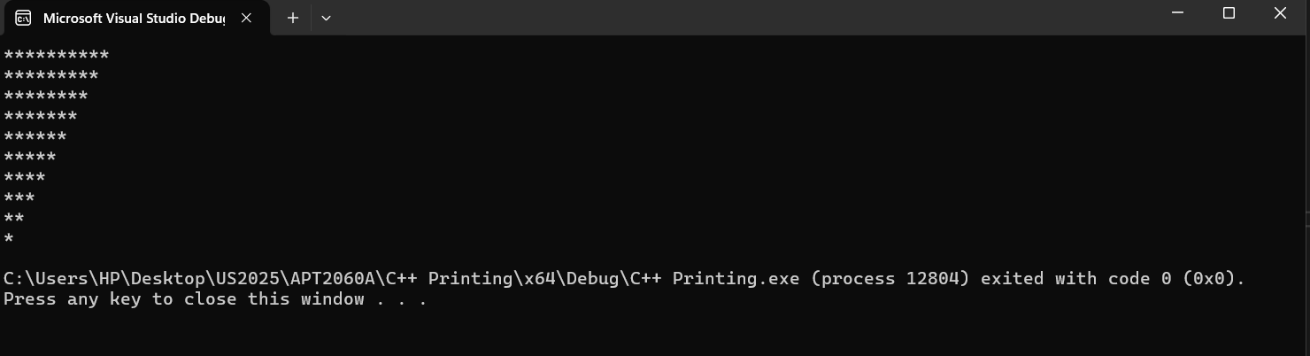
Question3
Code
#include <iostream>
#include <cmath>
using namespace std;
//C++ program for computing real roots of a quadratic equation
void roots_of_quadraticequation() {
double a, b, c, discriminant, root1, root2; // Initialize all variables properly
// ask the user to enter the a,b and c
cout << "Enter a,b,c. The general format of a quadratic equation is ax^2 + bx + c = 0 \n";
cin >> a >> b >> c; // Use >> for each variable, not comma
discriminant = (b * b) - (4 * a * c);
if (discriminant > 0) {
double square_root = sqrt(discriminant);
root1 = (-b + square_root) / (2 * a);
root2 = (-b - square_root) / (2 * a);
cout << "The real roots of the quadratic equation " << a << "x^2 + " << b << "x + " << c << " are:\n" << root1 << " and " << root2;
}
else if (discriminant == 0) {
root1 = (-b) / (2 * a);
cout << "The quadratic equation " << a << "x^2 + " << b << "x + " << c << " has one real root:\n" << root1;
}
else {
cout << "The quadratic equation " << a << "x^2 + " << b << "x + " << c << " has no real roots\n";
}
}
int main() {
roots_of_quadraticequation();
return 0; }
Code test
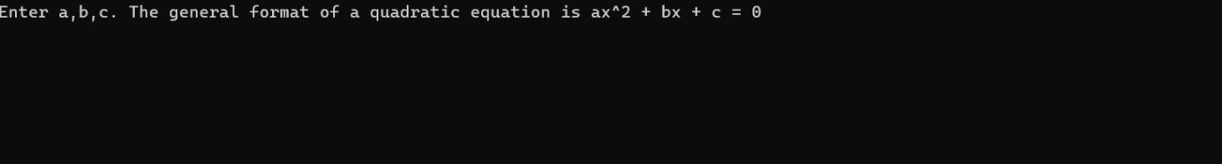
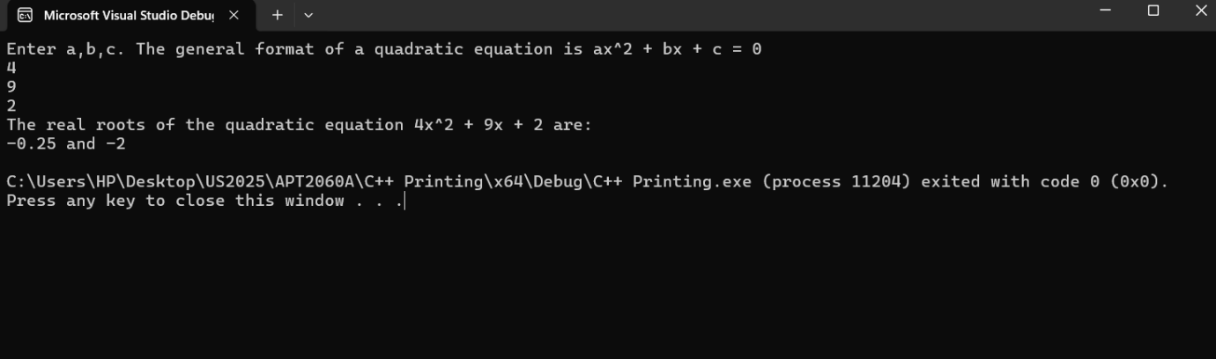
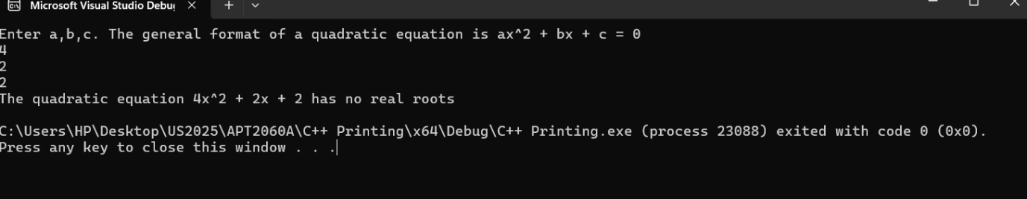
Question 4
Code
void tempreature_check() {
int days;
double temp;
double totalTemp = 0;

cout << "Welcome to the Daily Temperature Tracker!" << endl;
cout << "How many days do you want to record? ";
cin >> days;

// FOR LOOP: for each day
for (int i = 1; i <= days; i++) {
// WHILE LOOP: ensure valid temperature input
while (true) {
cout << "Enter temperature for Day " << i << " (in °C): ";
cin >> temp;

if (temp >= -50 && temp <= 60) {
break; // valid
}
else {
cout << "Invalid temperature. Please enter between -50°C and 60°C.\n";
}
}

// IF/ELSE to describe the temperature
if (temp < 15) {
cout << "It's a cold day.\n";
}
else if (temp <= 30) {
cout << "It's a normal day.\n";
}
else {
cout << "It's a hot day!\n";
}

totalTemp += temp;
}

// Calculate average
double average = totalTemp / days;

// Manual rounding to 1 decimal place
double rounded = ((int)(average * 10 + 0.5)) / 10.0;

cout << "\nAverage temperature over " << days << " days is: " << rounded << "°C\n";
}
int main() { tempreature_check();
return 0;
}
Code Test
